**Notes for :**

**Date:**

### Table of Contents

### Programming

### How machine understands the code

### operator precedence and associativity

### Input output Functions

### Datatypes

### Immutable & mutable Datatypes

### Indentation

### Operators in python

### Type checking

### Type casting / Type Conversion

### Handling Error(Exception Handling)

### Functions in python

### Types of Logic Gates

### **Programming**

Programming is the process of writing instructions (code) that a computer can understand and execute to perform a specific task.

### What is Python?

Python is a **high-level, interpreted programming language** that is widely used for various applications like web development, data science, automation, AI, and more.

* **Python is a popular programming language.**
* **It was created by Guido van Rossum and released in 1991 at CWI ( centrum wiskunde & informatica ) Netherland.**
* **Python is a general purpose language**
* **Python is High level language (reason it is written in general English language)**
* **Python is dynamic ( no need fo writing data type)**
* **Python code has indentation.**

### History Of Python

### Guido van Rossum started working on Python at CWI (Centrum Wiskunde & Informatica) in the

### Netherlands in late 1980’s

### Python 1.0 was officially released in 1991.

### Why Learn Python?

* **Easy to Learn** – Python has a simple and readable syntax, making it beginner-friendly.
* **Versatile** – Used in web development, machine learning, automation, game development, and more.
* **Large Community** – Millions of developers use Python, so you can find plenty of resources and help online.

### Key Features of Python:

* **Simple & Readable** – Looks almost like English.
* **Interpreted Language** – No need to compile; runs line by line.
* **Dynamically Typed** – No need to declare variable types.
* **Huge Libraries** – Supports many built-in libraries for tasks like data analysis, web development, and AI.

### Why is Python Platform-Independent?

1. **Interpreted Language** – Python code is executed by the Python interpreter, which is available for multiple operating systems.
2. **Write Once, Run Anywhere** – You don’t need to rewrite the code for different platforms.
3. **Cross-Platform Libraries** – Python libraries work on multiple OS without issues.

### How Python was named..

python was named after the British comedy show **"Monty Python's Flying Circus."**

Guido van Rossum, Python's creator, was a fan of the show and wanted a name that was **short, unique, and a bit mysterious**. He didn’t name it after the snake, but the association with a python (the reptile) became popular over time.

So, Python’s name comes from **Monty Python** and not from the snake!

### How Machine understands the code

Compiler converts the code ( set of instructions) which will be in High-level language in to Low level language i.e., in the form of 0’s and 1’s .

-- A machine (computer) reads **0s and 1s** internally using **electronic circuits** that operate on the principles of **binary logic** and **digital electronics**. Here's how it works step by step

**1. Electric Signals Represent 0 and 1**

* Computers use **electrical voltage levels** to represent binary values:
  + **High Voltage (e.g., +5V or +3.3V)** → Represents **1**
  + **Low Voltage (0V)** → Represents **0**
* These signals travel through circuits made of **transistors** (tiny electronic switches).

**2. Transistors Process Binary Data**

* A **transistor** acts as a switch:
  + If **current flows** → It represents **1**
  + If **no current flows** → It represents **0**
* Billions of transistors inside processors (CPUs, RAM, storage) work together to perform calculations.

**3. Logic Gates Perform Operations**

* **Logic gates** (AND, OR, NOT, etc.) are built using transistors.
* They process binary inputs and produce binary outputs.
* Example:
  + **AND Gate:** 1 AND 1 = 1, 1 AND 0 = 0
  + **OR Gate:** 1 OR 0 = 1, 0 OR 0 = 0
* These gates form circuits that perform arithmetic, store data, and control operations.

**4. Memory Stores 0s and 1s**

* **RAM (Random Access Memory):** Uses tiny capacitors that hold electrical charges (1) or no charge (0).
* **Hard Drives (HDDs):** Use magnetic fields to store binary data.
* **Solid-State Drives (SSDs):** Use flash memory, where transistors store charge states

**5. Data Transmission in Buses**

* Inside a computer, data (0s and 1s) moves through **buses** (electronic pathways) connecting CPU, RAM, storage, and other components.
* The CPU reads instructions and data by interpreting **binary signals**.

**6. Conversion to Human-Readable Form**

* Eventually, this binary data is **converted** into human-readable text, images, sounds, and videos using software and digital-to-analog converters.

### Basic “Hello world” program

### 

### Output:

### 

### Input & Output Functions

**print() – Display output**



**input() – Take input from user**

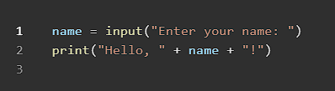

**By Default input() stores any value entered in to string format, so use type casting to convert the datatype.**

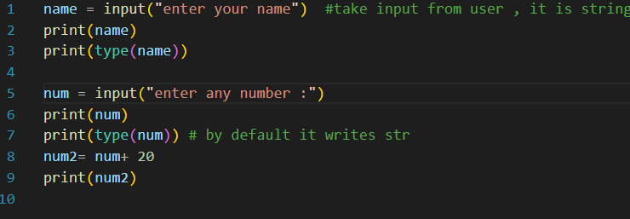

**OUTPUT**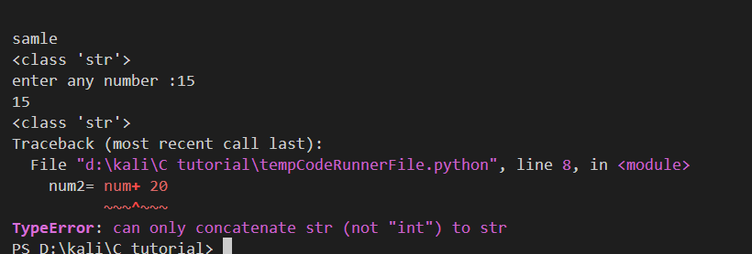

### Variables

### A variable is a named storage for data in memory, or the name of the container where the data is stored. In Python, you don't need to declare the type of a variable explicitly; it is dynamically assigned based on the value you store in it.

### So, python is known as the dynamic programming language.

* Variables store values and can hold different data types.
* Data types include int, float, str, list, tuple, set, dict, etc.

### Program for Declaring Variables

### 

### Explaination:

* x is assigned an **integer** value.
* name is assigned a **string**.
* price is assigned a **floating-point** value.
* is_active is assigned a **boolean** value.

**Rules for Naming Variables**

* Must start with a letter (A-Z or a-z) or an underscore _
* Can contain letters, numbers, and underscores
* Case-sensitive (myVar and myvar are different)
* Cannot use Python keywords (like if, else, class, etc.

### Invalid variable names:

### 

### Strings:

integer_value = 100

float_value = 4.5

boolean_value = True

boolean_value2 = False

# string declarations

string_value = "python course"

string_value2 = 'python course'

# multi line string declaration

string_value3 = """python

course

"""

print(len(string_value))

print(string_value[0])

print(string_value[-1])

# how to access any part of string

# with starting and ending point

# here it will include the value in starting index

# but not include the value in end index

print(string_value[0:5])

print(string_value[0:])

print(string_value[:5])

print(string_value[:])

### Output

### 

Escape Sequences in python:

# Escape sequences in python

# \"    - adds double quote

# \'    - adds single quote

# \\    - adds back slash

# \n   - new line

print("python  \"course")

print("python  \'course")

print("python  \\course")

print("python  \n course")

**output:**

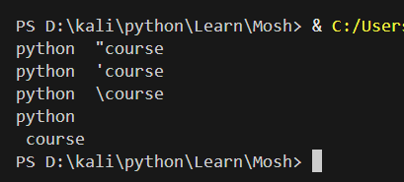

Using concatenation and F-string :

first = "Aakash"

last = "varma"

full = "first" + " " + last

format_string = f"{first} {last}"

format_string2 = f"{first}-----{last}"

print(full)

print(format_string)

print(format_string2)

print(f"""

      This type of formatting is used

      with help of f-string {first} and

      now we can add next variable {last}

""")

print(f"""

This type of formatting is used

      with help of f-string {len(first)} and

      now we can add next variable {5+6}

""")

**Output:**

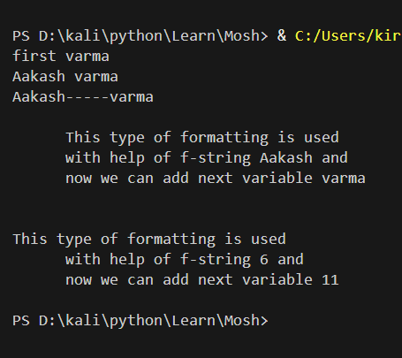

### DataTypes

Python has various **built-in data types**.

|  |  |  |
| --- | --- | --- |
| **Data Type** | **Example** | **Description** |
| **int** | x = 100 | Whole numbers |
| **float** | y = 10.5 | Decimal numbers |
| **str** | name = "Alice" | Text (string) |
| **bool** | flag = True | Boolean values (True/False) |
| **list** | fruits = ["apple", "banana"] | Ordered, mutable collection |
| **tuple** | point = (2, 3) | Ordered, immutable collection |
| **set** | nums = {1, 2, 3} | Unordered, unique elements |
| **dict** | person = {"name": "John", "age": 30} | Key-value pairs |

|  |  |  |
| --- | --- | --- |
| **Category** | **Data Type** | **Example** |
| **Numeric** | int | 100 |
|  | float | 10.5 |
|  | complex | 3 + 4j |
| **Boolean** | bool | True, False |
| **Text** | str | "Hello" |
| **Sequence** | list | ["a", "b"] |
|  | tuple | ("x", "y") |
|  | range | range(5) |
| **Set** | set | {1, 2, 3} |
|  | frozenset | frozenset({1, 2, 3}) |
| **Mapping** | dict | {"key": "value"} |
| **Binary** | bytes | b'hello' |
|  | bytearray | bytearray([65, 66]) |
|  | memoryview | memoryview(b'abc') |
| **None** | NoneType | None |

### Immutable & Mutablle Datatypes+

Immutable(means we cannot change the value)

Numbers

Strings

Tuples

***CODE to prove that these DataTypes are immutable.***

a= 10

print(id(a))

a=20

print(id(a))

mutable(means we can change the value)

Lists

Dictionary

Sets

### 1. Numeric Data Types

These include **integers, floating-point numbers, and complex numbers**.

**Integer (int)**

* Stores **whole numbers** (positive, negative, or zero).
* No decimal point.
* Unlimited precision (not fixed to 32-bit or 64-bit like in other languages).

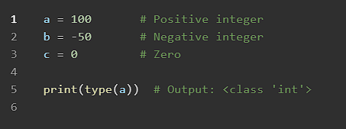

**Floating-Point (float)**

* Stores **decimal numbers**.
* Can represent very large or very small numbers.

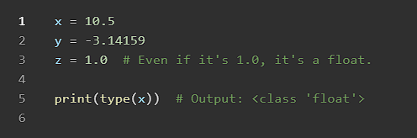

**Complex Numbers (complex)**

* Stores numbers in the form a + bj, where j is the imaginary unit (√-1).

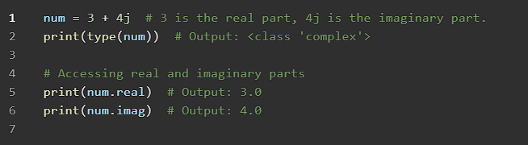

**2. Boolean (bool)**

• Represents True or False values.

• Used in **conditional statements** and **logical operations**.

• Internally, True = 1 and False = 0.

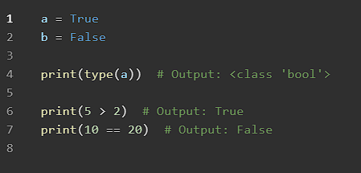

3. Text Data Type (str)

• Represents **sequences of characters** (text).

• Defined using single ('), double ("), or triple (''' """) quotes.

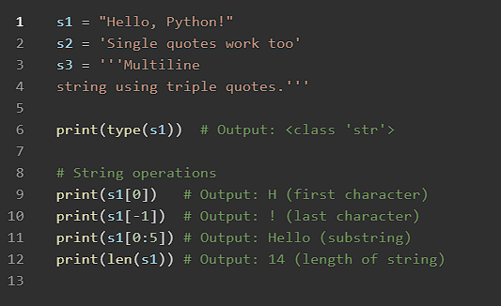

**4. Sequence Data Types**

These store **multiple values** in an **ordered manner**.

**List (list)**

* **Ordered** and **mutable** (can change elements).
* Can store different data types.

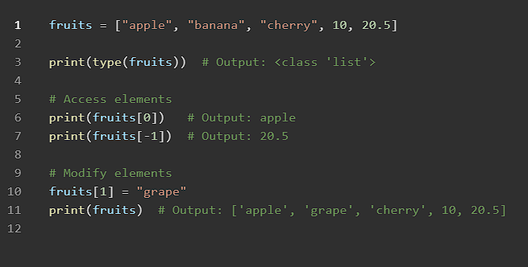

**Tuple (tuple)**

* **Ordered**, but **immutable** (cannot change elements after creation).
* Faster than lists.
* The values in tuples cant’t be changed

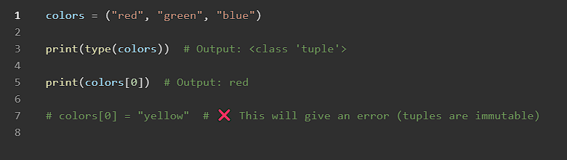

**Range (range)**

* Represents a **sequence of numbers**.
* Commonly used in loops.

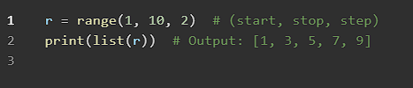

### 5. Set Data Types

**Set (set)**

* **Unordered** collection of unique elements.
* No duplicate values.
* Faster operations compared to lists.

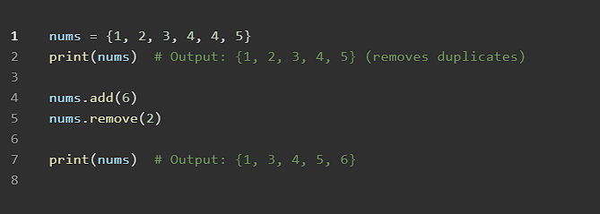

**Frozen Set (frozenset)**

* **Immutable version of a set**.
* Cannot add or remove elements.

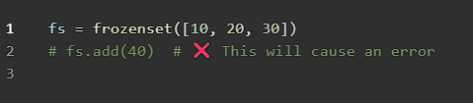

### **6. Dictionary (**dict**)**

• Stores **key-value pairs**.

• **Keys are unique** and **values can be of any type**

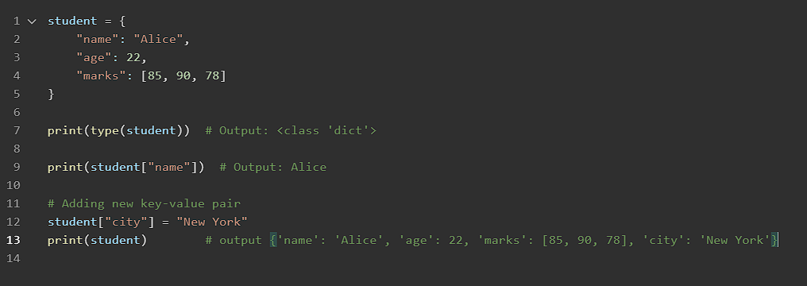

### 7. Binary Data Types

### Python provides special types for handling binary data.

**Bytes (bytes)**

* Immutable sequence of bytes.
* Used in handling **binary files** (images, videos, etc.).

### 

**Bytearray (bytearray)**

* Mutable version of bytes.

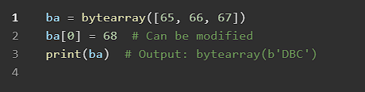

**Memoryview (memoryview)**

* Provides a **memory-efficient way** to access binary data.

### 

### 8. None Type (NoneType)

• Represents **null or empty values**.

### • Used when a variable **has no value assigned** yet.

### 

### **Operators in Python**

Operators are symbols that perform operations on variables and values. Python has different types of operators:

**1.Arithmetic Operators**

Used for mathematical operations.

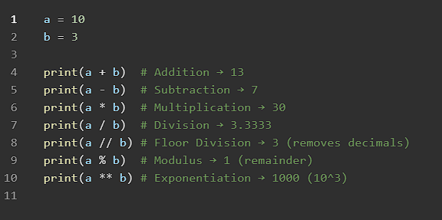

**2.Relationalc/comparision Operators**

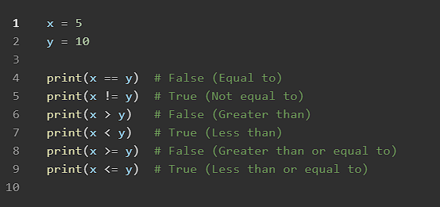

**3. Logical Operators**

Used to combine conditions

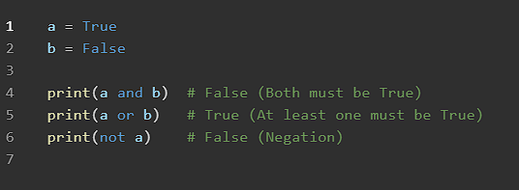

**4. Assignment Operators**

Used to assign values

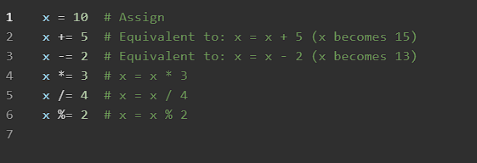

**5. Bitwise Operators**

Used for binary-level operations.

#Bitwise AND &

a = 0b1010

b = 0b1100

c = a&b

print(c) #output : 0b1000

#Bitwise OR “ | ” …|

a = 10

b = 20

c = a&b

print(c)

#Bitwise XOR ^

a = 0b1010

b = 0b1100

c = a^b

print(c)

# OR operators prints true is any one is true

#but XOR prints true when there are different inputs

T T = F

T F = T

F T = T

F F = F

#Bitwise NOT ~

a = 0b1010

b = 0b1100

c = ~a ( 0 is added before as positive sign 00000 1010, Bitwise NOT means compliment 0 to 1 , 1 to 0. (we added 0 in the beginning as a positive sign) 0 1010 ➡ 1 0101 (1 represents negative sign)

now inorder to represent this , we need to take 2’s compliment

1 0101

1’s compliment is 1010

Now add 1

1010

1

-----------

1011

( - sign) 1 1011 [this is the answer]

d= ~b

print(c)

print(b)

#Bitwise Left Shift << ( it is always multiply by 2)

a = 0b1010

b = 0b1100

c = a<<2 (always dividing by 2)

print(c)

#Bitwise Right Shift >>

a = 0b1010

b = 0b1100

c = a>>2

print(c)

program:

a=10

b=20

c=0b1010

d=0x1011

e=a&b

f=a|b

g=a^b

i=~a #

j=~b #bitwise NOT

print(bin(a))

print(hex(a))

print(oct(a))

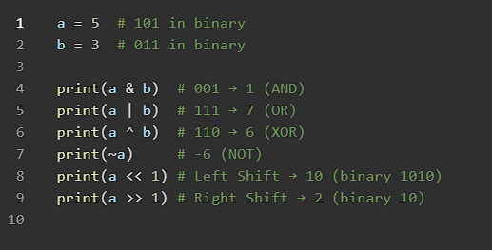

**6. Identity Operators**

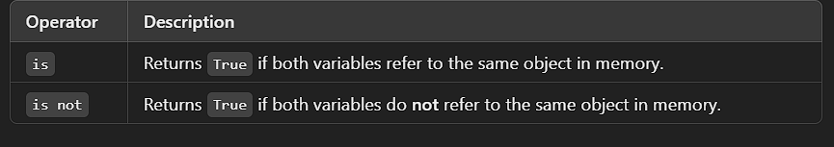

**program:**

a=10

b=10

print(a is b)

print(a is not b)

print(id(b))

print(id(a))

list1=[1,3,5]

list2=[1,3,5]

print(list1 is list2) #checks object means where it is stored(location ID)

print(list1 == list2) #checks value in the location

**7. Membership Operators**

Checks wheather is in the part of the existing data, example to check userid id

list1=[1,10,20]

print(10 in list1)

### Operator precedence & Associativity

|  |  |  |  |
| --- | --- | --- | --- |
| **Precedence** | **Operator(s)** | **Description** | **Associativity** |
| **1 (Highest)** | () | Parentheses (Grouping) | Left to Right |
| **2** | ** | Exponentiation | Right to Left |
| **3** | +x, -x, ~x | Unary Plus, Unary Minus, Bitwise NOT | Left to Right |
| **4** | *, /, //, % | Multiplication, Division, Floor Division, Modulus | Left to Right |
| **5** | +, - | Addition, Subtraction | Left to Right |
| **6** | <<, >> | Bitwise Shift Left, Bitwise Shift Right | Left to Right |
| **7** | & | Bitwise AND | Left to Right |
| **8** | ^ | Bitwise XOR | Left to Right |
| **9** | | | Bitwise OR | Left to Right |
| **10** | ==, !=, >, <, >=, <=, is, is not, in, not in | Comparison, Identity, and Membership Operators | Left to Right |
| **11** | not | Logical NOT | Left to Right |
| **12** | and | Logical AND | Left to Right |
| **13** | or | Logical OR | Left to Right |
| **14 (Lowest)** | =, +=, -=, *=, /=, //=, %=, **=, &=, |=, ^=, >>=, <<= | Assignment Operators | Right to Left |

print(10*2+3/3-4)

### output: ⬇

### 

Indentation in Python

Indentation in Python refers to the spaces or tabs at the beginning of a line of code. Unlike other programming languages that use {} (curly brackets) to define code blocks, Python relies on indentation to indicate block structures like loops, conditionals, and function definitions.

**Why is Indentation Important?**

1. **Defines Code Blocks**
   * In Python, indentation is not just for readability; it is **mandatory**.
   * Without proper indentation, Python will throw an error.
2. **Improves Readability**
   * Indentation helps in structuring code in a clear and understandable way.
3. **Prevents Errors**
   * Incorrect indentation will lead to IndentationError or unexpected behavior in programs

Correct indentation

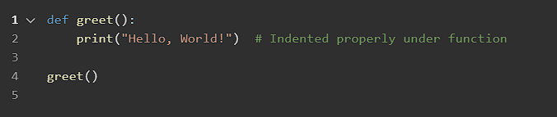

Wrong Indentation

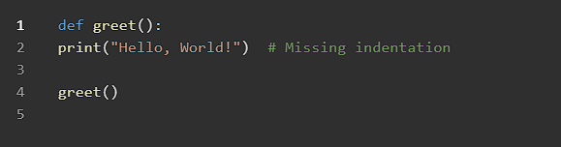

Expected Error: IndentationError: expected an indented block

**Indentation in Conditional Statements:**

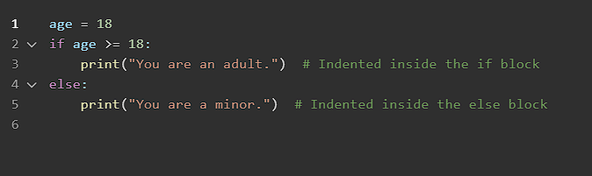

**Indention in LOOPS**

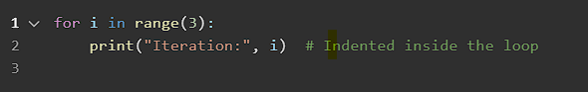

### Indention with Nested Structures

**How Many Spaces for Indentation?**

* Python **PEP 8 (style guide)** recommends using **4 spaces per indentation level**.
* Using **tabs and spaces together** can cause errors.

### Recommended 4 spaces

### 

* Python uses indentation to define code blocks.
* Always use **4 spaces per indentation level** (avoid mixing spaces and tabs).
* Improper indentation leads to IndentationError.
* Proper indentation makes code **readable** and **error-free**.

### Type Checking and Type Conversion in Python

Python is a dynamically typed language, meaning that variables do not have explicit types and can change type during execution. However, checking and converting types can be useful for ensuring data integrity and avoiding errors.

### **1. Type Checking**

Type checking refers to verifying the data type of a variable or object.

### **Using** type()

The type() function returns the type of an object.

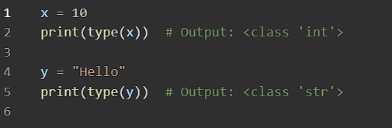

### Using isinstance()

The isinstance() function checks whether a variable is an instance of a particular type.

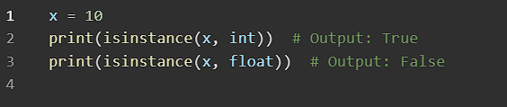

### You can check for multiple types using a tuple:

### 

### 2. Type Conversion (Type Casting)

Type conversion is the process of converting one data type into another.

**Implicit Type Conversion (Automatic)**

Python automatically converts one type to another when needed.

### 

**Explicit Type Conversion (Manual)**

Python provides built-in functions to convert types manually.

| **Function** | **Converts To** |
| --- | --- |
|  |  |
|  |  |

|  |  |  |  |  |  |  |  |  |  |  |  |  |  |  |  |  |  |
| --- | --- | --- | --- | --- | --- | --- | --- | --- | --- | --- | --- | --- | --- | --- | --- | --- | --- |
| |  |  | | --- | --- | | int(x) | Integer | | float(x) | Floating point number | | str(x) | String | | bool(x) | Boolean | | list(x) | List | | tuple(x) | Tuple | | set(x) | Set | | dict(x) | Dictionary | |  |
|  |  |

### Examples for Type conversion :

### 

### 3. Handling Errors in Type Conversion:

When converting types, invalid conversions can cause errors.

### 

• **Type Checking**: Use type() or isinstance().

• **Type Conversion**:

Implicit: Python automatically converts types where needed.

Explicit: Use built-in functions like int(), float(), str(), list(), etc.

• **Error Handling**: Use try-except for invalid conversions.

### Functions in Python

A **function** is a block of code that performs a specific task. Functions help in **code reusability**, **organization**, and **modularity**

### **1. Types of Functions in Python**

Python has two types of functions:

1. **Built-in Functions** – Predefined in Python (e.g., print (), len(), max(), min()).
2. **User-Defined Functions** – Created by programmers using the def keyword.

### **2. Creating a User-Defined Function**

### **Basic Function**

def sample():

    print("Hello, students Good morning !")

sample()  #calling the function

#OUTPUT : Hello, students Good morning !

### • def sample(): → Defines a function named sample.

• print("Hello,Students Good morning !”) → Code inside the function runs when it's called.

• sample() → Calls the function to execute.

### 3. Function with Parameters

### Functions can accept values (parameters) to work with.

def hai(name):

    print ("hello " + name +"!")

hai("Bunty") #output : hello Bunty!

* name is a parameter that takes different values when the function is called.

### **4. Function with Return Value**

A function can return a result using return

def add(a,b):

    return a+b

result = add(5,10)

print(result )   #output: 15

• The function add(a, b) takes two numbers and returns their sum.

• return gives back the result to the caller.

### 5.Default Parameter Values

If a parameter is not provided, a default value is used.

def hai(name="Default_Name"):

    print ("hello " + name +"!")

hai("Bunty") #output : hello Bunty!

hai()

#if we wont provide any value for decalered

# parameter in function arguments, it will take default

#value

#OUTPUT: hello Bunty!

#         hello Default_Name!

### **7. Lambda (Anonymous) Functions**

A **lambda function** is a small anonymous function used for short tasks.

# writes odd numbers and filters means skips the numbers that are divisible by 2

"""

num = [10, 12,19, 13,25,35,36,16]

def even(x):

    return x % 2

evens = list(filter(even, num))

print (evens)

"""

#writes only even numbers that satisfies the condition inside the function

num = [10, 12,19, 13,25,35,36,16]

def even(x):

    return x % 2 ==0

evens = list(filter(even, num))

print (evens)

-------------------------------------------------------------------------------

#using Lambda function and mainly used for temporary purpose

num = [10, 12,19, 13,25,35,36,16]

evenn = list(filter( lambda x : x % 2 ==0, num)) # lambda function is mainly used for, when only sorted, filtered, or mapped

print (evenn)

### **8. Function with Arbitrary Arguments (**\*args **&** **kwargs**)**

### **Using** *args **(Multiple Positional Arguments)**

### 

### Using **kwargs (Multiple Keyword Arguments)

### 

**Functions** help organize code and avoid repetition.  
 Use def to define a function.  
 Functions can have **parameters**, **return values**, and **default values**.  
 lambda creates small, **anonymous functions**.  
 *args allows multiple **positional** arguments.  
 **kwargs allows multiple **keyword** arguments.

### 

### Notes For Date:

### Type Casting:

### Program: ⬇

Num1= input("enter first number :")

Num2= input("enter second number :")

print(Num1+Num2)

### Output ⬇

### 

* Output is concatenated
* Input is stored in the form of “STR string” data type.
* We need to change the Datatype explicitly.
* Use explicit type casting function [ int() or float() or char()…. ]

Num1= int(input("enter first number :"))

Num2= int(input("enter second number :"))

print(Num1+Num2)

### output ⬇

### 

### Implicit Type casting of Datatypes ⬇

Num1= 10

Num2= 20.5 # this is float datatype

add= Num1+Num2 #answer will be in float datatype int + Float = float

print(add)

print(type(add)) #lets check the type of add datatype

### output ⬇

### 

### Example program for practice:

Here we used

float(), to print give integer in float

oct(), to print give integer in octa decimal

hex(), to print give integer in hexa decimal

bin(), to print give integer in Binary number

ord(),

num = 15

f = float(num)

print(f)

H = hex(num)

print(H)

O = oct(num)

print(O)

B = bin(num)

print(B)

#for ASCII value

char = "A"

print(ord(char))

### output ⬇

### 

### Escape character ⬇

These are special characters used to represent non-printable or special characters within the string

\ : backslash

\n : newline

\t : tab

\r : carriage return

print(' I'll call you later')

output error ⬇

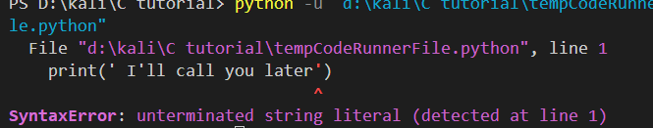

To allow any string to print any special character ⬇

print(" I'll call you later")

or

print(' I\'ll call you later')

print(" this is important \"topic\" here ")

print(" this is \t important \n here ")

output: ⬇



\r (carriage return)

print(" This escape character is used to \r shift the part to beginning ")

### output: ⬇

### 

### Types of Logic Gates in Python

# AND Gate

salary= 2000

age= 18

if age>19 and salary>2000:

    print("True")

else:

    print("False")

# OR Gate

salary= 2000

age= 18

if age>19 or salary>1000:

    print("True")

else:

    print("False")

# NOT Gate

a= True

b= False

if not a:

    print("condition becomes false now")

else:

    print("now it will print this becase it is false")

# NAND Gate

**NAND Gate (NOT (A AND B))**:

# NOR Gate

NOR Gate (NOT (A OR B))

# XOR Gate

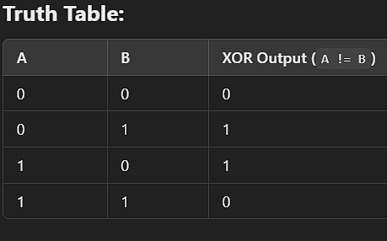

# XNOR Gate

### 

### Formatting in Python

### Using f-strings only in versions (Python 3.6+)

name = "meghana"

age = 25

print(f"My name is {name} and I am {age} years old.")

### output

### 

### formatting numbers( old method)

pi = 3.14159

print(f"Pi rounded to 2 decimal places: {pi}")

pi = 3.14159

print(f"Pi rounded to 2 decimal places: {pi:.10f}")

### Methods ⬇

### Using Method .format()

name = "raju"

age = 30

print("My name is {} \n and I am {} years old.".format(name, age))

### output ⬇

### 

### **With Indexed Placeholders:**

name= "ayshu"

age= "16"

roll_no = 101

city= "piler"

print("My name is {1} and I am {0} years old.".format(age, name))

print("My name is {1} and I am {0} years old. I live in {2} adn my roll number is {3}".format(age, name,city,roll_no))

### string Methods ⬇

a = "10"

# string methods

text = "  Hello, students! , project "

value = "python course"

value2 = "   python course   "

print(a.isdigit())  # to check value is in digits or not

print(text.lower())  # lowercase

print(text.upper())  # uppercase

print(text.strip())  # Remove whitespace

print(text.replace("project", "World"))  # Replace substring

print(text.split(","))  # Split into a list

print(value.title())  # capatilze the starting letter

print(value2.lstrip())  # removes white space from beginning of string

print(value2.rstrip())  # removes from end

### LIST Methods ⬇

#list methods

fruits = ["apple", "banana", "cherry"]

fruits.append("orange")  # Add element at the end

fruits.insert(1,"grape")  # Insert at a specific index

fruits.remove("banana")  # Remove an element

fruits.pop()  # Remove the last item

fruits.reverse()  # Reverse the list

fruits.sort()  # Sort the list (ascending order)

### Dictionary Methods ⬇

#dictionary methods

print(fruits)

student = {"name": "John", "age": 25, "city": "New York"}

print(student.keys())  # Get all keys

print(student.values())  # Get all values

print(student.items())  # Get key-value pairs as tuples

student.update({"age": 26})  # Update value

student.pop("city")  # Remove key-value pair

print(student)

### Tuple Methods ⬇

#Tuple methods

numbers = (10, 20, 30, 40, 20, 50)

print(numbers.count(20))  # Count occurrences of 20

print(numbers.index(30))  # Find index of 30

### set Methods ⬇

#set methods

set1 = {1, 2, 3, 4}

set2 = {3, 4, 5, 6}

print(set1.union(set2))  # Combine sets

print(set1.intersection(set2))  # Common elements

print(set1.difference(set2))  # Elements in set1 but not in set2

### File Handling Methods ⬇

#file handling methods

set1.add(10)  # Add an element

set1.remove(2)  # Remove an element

### Math Methods ⬇

#math methods

import math

print(math.sqrt(16))  # Square root

print(math.ceil(4.2))  # Round up

print(math.floor(4.9))  # Round down

print(math.pow(2, 3))  # Power (2^3)

print(math.factorial(5))  # Factorial of 5

### Random module Methods ⬇

#random module methods

import random

print(random.randint(1, 10))  # Random integer

print(random.choice(["apple", "banana", "cherry"]))  # Random choice

print(random.shuffle([1, 2, 3, 4, 5]))  # Shuffle list

### DateTime Methods ⬇

#datetime methods

from datetime import datetime

now = datetime.now()

print(now.strftime("%Y-%m-%d %H:%M:%S"))  # Format date and time

### OS module Methods ⬇

#os module method

import os

print(os.getcwd())  # Get current working directory

print(os.listdir())  # List files in directory